CISCO PACKET TRACER

Prepared By: Er. Sharat Maharjan, Prime College

Lab 1: Creating a Peer-to-Peer Network


- Equipment needed
  - 2 Workstations
  - 1 Ethernet cable

- Identify the cable (straight through or cross over) and connect the workstations I.e; PC1 and PC2.

- Configure the layer 3 address to the workstations
  - PC1-- 192.168.1.1/24
  - PC2-- 192.168.1.2/24

- Verify Connectivity (ping command)
  - Ping PC2 from PC1.

Lab 2: Implement the LAN Topologies

Topology 1: Star Topology

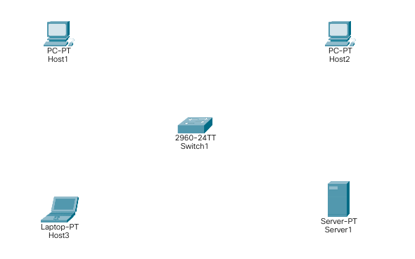
Device | Interface | IPv4 Address | Subnet Mask
Host1 | NIC | 192.168.10.101 | 255.255.255.0
Host2 | NIC | 192.168.10.102 | 255.255.255.0
Host3 | NIC | 192.168.10.103 | 255.255.255.0
Server1 | NIC | 192.168.10.104 | 255.255.255.0

- Design the given topology.
- Configure the layer 3 address to all nodes according to addressing table.
- From the command prompt on each node, run the ping test and write the output.
  - Can Host1 ping Server1?
  - Can Server1 ping Host3 and Host2?

Topology 2: Bus Topology

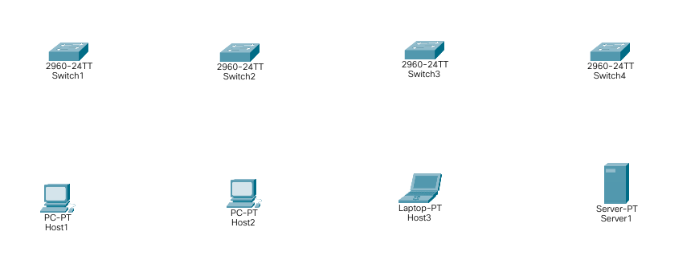
Device | Interface | IPv4 Address | Subnet Mask | Switch
Host1 | NIC | 192.168.11.101 | 255.255.255.0 | Switch1
Host2 | NIC | 192.168.11.102 | 255.255.255.0 | Switch2
Host3 | NIC | 192.168.11.103 | 255.255.255.0 | Switch3
Server1 | NIC | 192.168.11.104 | 255.255.255.0 | Switch4

- Design the given topology.
- Assign the IP address to all nodes according to addressing table.
- From the command prompt on each node, run the ping test and write the output.
  - Can Host1 ping Server1?
  - Can Server1 ping Host3 and Host2?

Topology 3: Ring Topology

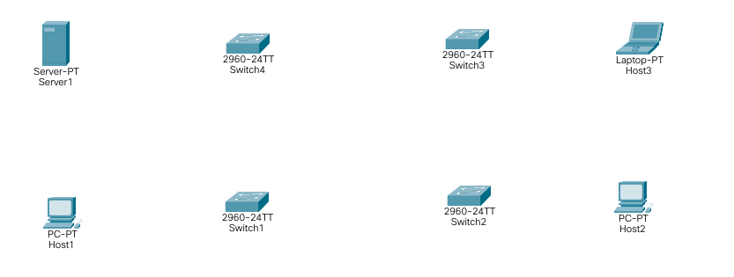

Device | Interface | IPv4 Address | Subnet Mask | Switch
Host1 | NIC | 192.168.100.101 | 255.255.255.0 | Switch1
Host2 | NIC | 192.168.100.102 | 255.255.255.0 | Switch2
Host3 | NIC | 192.168.100.103 | 255.255.255.0 | Switch3
Server1 | NIC | 192.168.100.104 | 255.255.255.0 | Switch4

- Design the given topology.
- Assign the IP address to all nodes according to addressing table.
- From the command prompt on each node, run the ping test and write the output.
  - Can Host1 ping Host3?
  - Can Server1 ping Host2?

